Lecture two: Population Distributions and Non-parametric
Estimations of Survival Function

- Survival function and hazard function
  - Cumulative Function and Survival Function
The actual survival time of an individual, t, can be regarded as the realization of a random variable T, which can take any non-negative value.
    - The distribution of the population survival is often unknown
    - Any theoretical distribution to approximate the true one?
    - Only few theoretical distributions available (e.g. exponential, Weibull, etc)
    - Empirical distribution that is solely based on data (non-parametric)

Definition of Survival Distribution:

S(t) = pr(T > t) = 1 – pr(T<= t) = 1 – F(t)

- F(t): cumulative frequency distribution (of failure)
- S(t): proportion of survivors
- 0<= S(t) <= 1; non-increasing, right continuous and has left limits; S(0) = 1, $S(+∞)=0\text{.}$
- F(t) or S(t) does not tell directly the failure rate at time t and failure rate at time t given survival

  - Density Function:

f(t) = dF(t) / dt

- Interpretation: Relative frequency distribution or failure rate
- Limiting distribution of relative frequency when segment window has arbitrarily small length
- f(t) ≥0; integration of f(t) equals to one
- Density function does not tell directly instantaneous risk or rate of failure GIVEN at risk

  - Hazard Function:

h(t) = lim_{δ→0} Pr(failure in (t, t + δ] | survival at t)/δ

- Instantaneous/conditional failure rate
- Age-specific failure rate
- Force of mortality
- Non-negative; unbounded from above
- Example: h(t) = constant
- Cumulative Hazard: H(t)

  - Relationships between S(t), F(t), h(t) and H(t):
  - Example: h(t) = λ (i.e. exponential distribution)

  - Mean Residual Life time (mrl):

mrl(t₀) = E[T- t₀ | T ≥ t₀],

i.e.,mrl(t₀) = average remaining survival time given the population has survived
beyond t₀. It can be shown that

mrl(0) = E(T). For exponential distribution, mrl(t₀) = E(T).

- Estimating the Survivor Function – nonparametric approach

  - Assumptions

- Observation on any one individual is independent of those on others
- Random/independent censoring
- Statistical implication of random censoring: censoring time and true survival time are independent conditioning on survival history

  - Empirical survivor function

In the absence of censoring

  - Instantaneous risk of failure (or conditional failure rate) between two arbitrary time points: (t_{j-1}, t_{j}]

q(t_{j-1},t_{j}) = Pr{failure in (t_{j-1}, t_{j}] given survival at t_{j-1}} = (S(t_{j-1}) – S(t_{j}))/ S(t_{j-1})

- 0<= q(t) <= 1
- Sample estimate:
$\hat{q}(t_{j−1},t_{j})=${# of deaths in (t_{j-1}, t_{j}]}/{# of survivors at t_{j-1}}
or
$\hat{q}(t_{j−1},t_{j})=${# of deaths in (t_{j-1}, t_{j}]}/{average # of survivors during ( t_{j-1,} t_{j}]}
  - Life-table and Kaplan-Meier/Product-Limit Estimate of S(t)

Suppose we want to estimate S(t), the population proportion surviving beyond time t.

- Survival history can be described by the conditional probabilities or instantaneous risk, q(s, t). Let’s pick up a sequence of time points leading to t (divide and conquer?):
t₀ = 0 < t₁ < … < t_{j-1} < t

S(t) = Pr(T > t) = Pr(T > t_{j-1}) * Pr(T > t Given T > t_{j-1})
= Pr(survive beyond t_{j-1} )*Pr(No Failure in (t_{j-1}, t] | T > t_{j-1})
= S(t_{j-1})*(1 – q(t_{j-1}, t))
= S(t_{j-2})*(1-q(t_{j-2}, t_{j-1}))(1- q(t_{j-1}, t))
= (1-q(t₀, t₁))*…*(1- q(t_{j-2}, t_{j-1}))(1- q(t_{j-1}, t))

- Life-table (or actuarial) estimate:

  - Dividing the period of observation into a series of time intervals: $t_{j}^{'}$ to $t_{j+1}^{'}$, j = 1, 2, …,m
  - $d_{j}$ deaths, c_{j} censored in ($t_{j}^{'}$, $t_{j+1}^{'}$] and n_{j} at risk at the start of the j’th interval
  - Assume censored times occur uniformly (i.e. U(0, c_{j})) through the j’th interval, then average number of individual at risk is $n_{j}^{'}=n_{j}−{c_{j}}/2$
- The probability of survival beyond time $t_{k}^{'}$, k = 1, 2, …,m is
$S(t)=\prod_{j=1}^{k}{(}n_{j}^{'}−d_{j})/{n_{j}^{'}}$
for $t_{k}^{'}$ ≤ t < $t_{k+1}^{'}$, k = 1, 2, …,m

- For KM estimate:

Choose above sequence as the distinguish death times: Observed survival times: t₁, t₂, …, t_{n}; death times: t₍₁₎ < t₍₂₎ < … < t_{(r)}; n_{j} at risk just before t_{(j)}, d_{j} deaths at t_{(j)}

$$\hat{S}(t)=\prod_{j=1}^{k}{(n_{j}}−d_{j})/{n_{j}}$$
for t_{(k)} ≤ t < t _{(k+1),} k = 1,2, 3,…,r

  - The largest observation is censored? Undefined beyond that time; otherwise is zero (largest observation is event).
  - Censoring time and death time occur simultaneously?
Assume censored time(s) occur(s) right after the death time(s).
- Nelson-Aalen estimate:

$$\tilde{S}(t)=\prod_{j=1}^{k}{\text{exp}(}−{d_{j}}/{n_{j}})$$
for t_{(k)} ≤ t < t _{(k+1),} k = 1,2, 3,…,r.

- The above estimate can be derived from an estimate of the cumulative hazard function, using Taylor expansion of log (1-x).
- KM estimate can be regarded as approximation to the Nelson-Aalen estimate, using Taylor expansion of e^{-x}.
- The Nelson-Aalen estimate of survivor function ≥ KM estimate at any given time.
- Small-sample properties; and large-sample properties.
- Examples:
Example 2.2 (p17):
Output:
Life Table Survival Estimates
Interval Num. Num. Sample Probability Standard
[Lower, Upper) Failed Censored Size of Failure Error
0 12 16 4 46.0 0.3478 0.0702
12 24 10 4 26.0 0.3846 0.0954
24 36 1 0 14.0 0.0714 0.0688
36 48 3 1 12.5 0.2400 0.1208
48 60 2 2 8.0 0.2500 0.1531
60 . 4 1 4.5 0.8889 0.1481
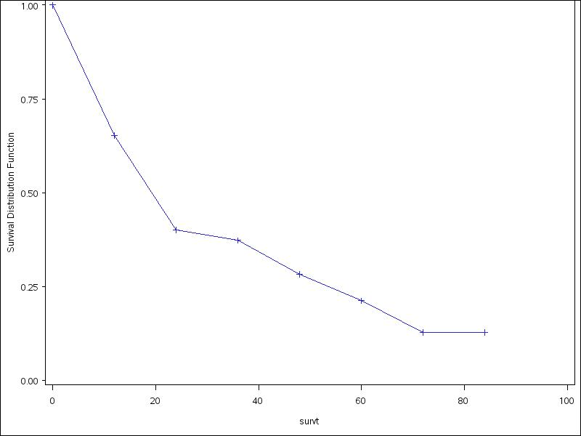

SAS program:
Options ls = 80;
libname fu '../sdata';
data fu.myeloma;
infile "../data/myeloma.dat" ;
input pid survt censor age sex bun ca hb pc bj;
proc lifetest plots=(s) method =life width=12;
time survt*censor(0);
run;

Example 2.3 (p23): KM estimate
Output:
The LIFETEST Procedure
Product-Limit Survival Estimates
Standard Number Number
SURVT Survival Failure Error Failed Left

0.000 1.0000 0 0 0 18
10.000 0.9444 0.0556 0.0540 1 17
13.000* . . . 1 16
18.000* . . . 1 15
19.000 0.8815 0.1185 0.0790 2 14
23.000* . . . 2 13
30.000 0.8137 0.1863 0.0978 3 12
36.000 0.7459 0.2541 0.1107 4 11
38.000* . . . 4 10
54.000* . . . 4 9
56.000* . . . 4 8
59.000 0.6526 0.3474 0.1303 5 7
75.000 0.5594 0.4406 0.1412 6 6
93.000 0.4662 0.5338 0.1452 7 5
97.000 0.3729 0.6271 0.1430 8 4
104.000* . . . 8 3
107.000 0.2486 0.7514 0.1392 9 2
107.000* . . . 9 1
107.000* . . . 9 0

NOTE: The marked survival times are censored observations.

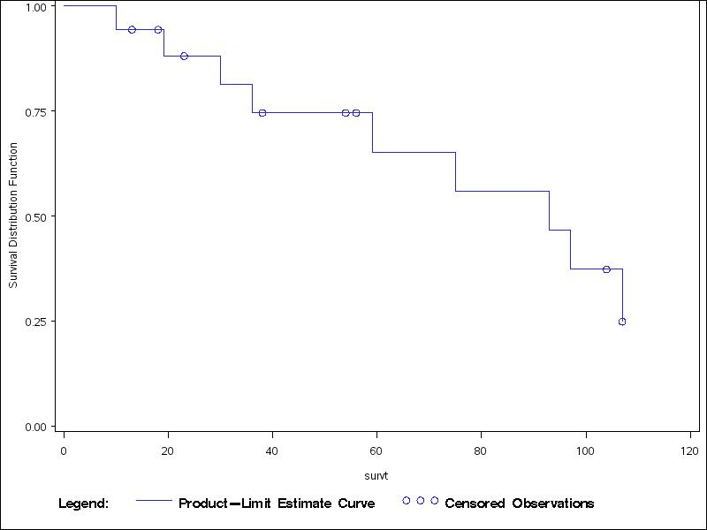

SAS program:

* create sas dataset from ASCII file iud.dat;
Options ls = 80;
libname fu '../sdata';
data fu.iud;
infile "../data/iud.dat";
input survt censor;
* run lifetest procedure;
filename gsasfile 'iud.gsf';
goptions gaccess=gsasfile ROTATE=LANDSCAPE gsfmode=replace device=ps;
proc lifetest plots=(s) method =km;
time survt*censor(0);
run;

Example 2.4 (p20): Nelson-Aalen estimate of survivor function - SAS program only:

Options ls = 80;
libname fu '../sdata';
data w;
set fu.iud;
proc lifetest method =PL NELSON;
time survt*censor(0);
run;

Assignment two: Calculate Kaplan-Meier estimate of survivor function for chronic active hepatitis data set (Table B.1, p499) by hand for each treatment group (i.e. Prednisolone and Control); and verify your results using statistical software (e.g. SAS).

Reading assignment: read sections 1.5, 1.6.

