**The connection between Cox (PH) modelling and the log-rank test**

Assuming no ties at t(j), j = 1, …, r, dj = d1j + d2j = 1, xi = 1 (group 1) or 0 (group 2)

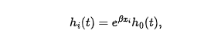

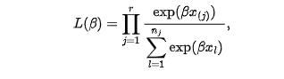

Then (since nj = n1j + n2j),



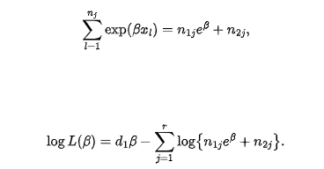

Where



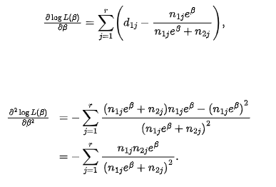

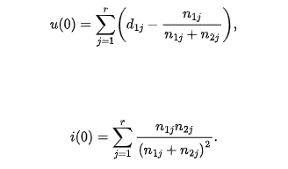

The score test statistic under the null hypothesis that β = 0, *u*2(0)/*i*(0) has a chi-square distribution with one degree of freedom.

Recall (since dj = 1, thus nj – dj = nj – 1, dj(nj – dj) = (nj – 1)): 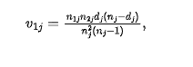



Thus, *u*2(0)/*i*(0) = *U2L/VL.*